Factory of Factory is known as abstract factory.

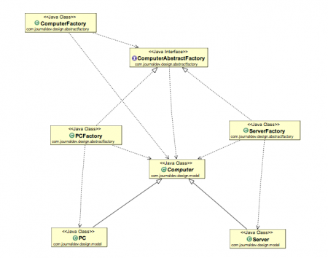

Abstract Factory Design Pattern Benefits
- Abstract Factory design pattern provides approach to code for interface rather than implementation.
- Abstract Factory pattern is “factory of factories” and can be easily extended to accommodate more products, for example we can add another sub-class Laptop and a factory LaptopFactory.
- Abstract Factory pattern is robust and avoid conditional logic of Factory pattern.

Abstract Factory Design Pattern Examples in JDK
- javax.xml.parsers.DocumentBuilderFactory#newInstance()
- javax.xml.transform.TransformerFactory#newInstance()
- javax.xml.xpath.XPathFactory#newInstance()

package com.test.design.pattern.abstractFactory;

public abstract class Computer {

public abstract String getHdd();

public abstract String getCpu();

public abstract String getRam();

@Override
public String toString() {
return "Hdd :->" + getHdd() + " Cpu :->" + getCpu() + " ram :->"
+ getRam();
}

}

package com.test.design.pattern.abstractFactory;

public class ComputerAbstractFactory {

public static Computer getComputerAbstractFactory(ComputerFactory computerFactory) {
return computerFactory.createComputer();
}

}

package com.test.design.pattern.abstractFactory;

public interface ComputerFactory {
public Computer createComputer();
}

package com.test.design.pattern.abstractFactory;

public class PC extends Computer {
private String hdd;
private String cpu;
private String ram;

public PC(String hdd, String cpu, String ram) {
this.hdd = hdd;
this.ram = ram;
this.cpu = cpu;
}

@Override
public String getHdd() {
return hdd;
}

@Override
public String getCpu() {
return cpu;
}

@Override
public String getRam() {
return ram;
}

@Override
public String toString() {
return "PC [hdd=" + hdd + ", cpu=" + cpu + ", ram=" + ram + "]";
}

}
package com.test.design.pattern.abstractFactory;

public class PCFactory implements ComputerFactory{
private String hdd;
private String cpu;
private String ram;

public PCFactory(String hdd, String cpu , String ram){
this.hdd = hdd;
this.cpu = cpu;
this.ram = ram;
}

@Override
public Computer createComputer() {
return new PC(hdd , cpu, ram);
}

}
package com.test.design.pattern.abstractFactory;

public class Server extends Computer {

private String hdd;
private String cpu;
private String ram;

public Server(String hdd, String cpu, String ram) {
this.hdd = hdd;
this.cpu = cpu;
this.ram = ram;
}

@Override
public String getHdd() {
return hdd;
}

@Override
public String getCpu() {
return cpu;
}

@Override
public String getRam() {
return hdd;
}

@Override
public String toString() {
return "Server [hdd=" + hdd + ", cpu=" + cpu + ", ram=" + ram + "]";
}

}
package com.test.design.pattern.abstractFactory;

public class ServerFactory implements ComputerFactory {

private String hdd;
private String ram;
private String cpu;

public ServerFactory(String hdd, String cpu, String ram) {
this.ram = ram;
this.hdd = hdd;
this.cpu = cpu;
}

@Override
public Computer createComputer() {
return new Server(hdd, cpu, ram);
}

}
package com.test.design.pattern.abstractFactory;

public class TestAbstractFactoryPattern {

public static void main(String args[]) {
PCFactory pcFactory = new PCFactory("100 GB SATA", "I-5 Core Processor", "8GB DDR RAM");
Computer pc = ComputerAbstractFactory.getComputerAbstractFactory(pcFactory);
System.out.println(pc);

ServerFactory serverFactory = new ServerFactory("400 GB SATA", "I-8 Core duo Processor", "32GB DDR RAM");
Computer server = ComputerAbstractFactory.getComputerAbstractFactory(serverFactory);
System.out.println(server);
}

}

